1-5 UML Diagram

Dhiraj Gurung

Southern New Hampshire University

CS230

Barbara Hecker

January 8, 2025

**UML Diagram**

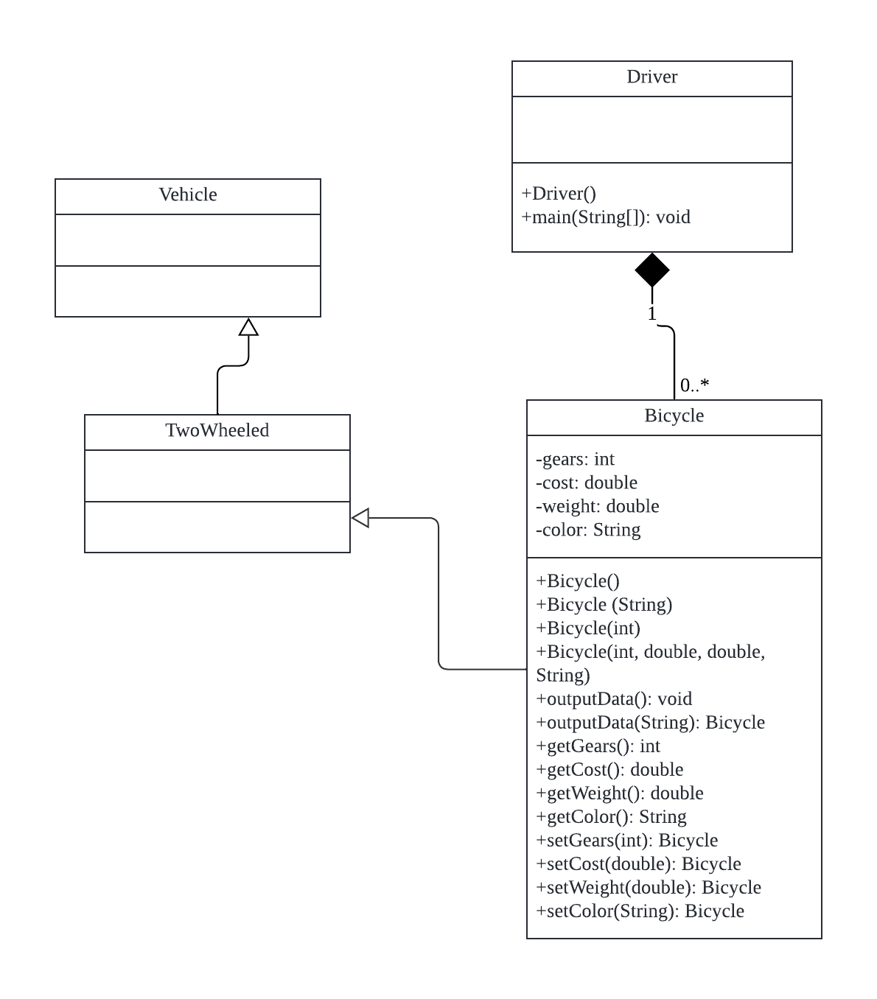

**Explanation:**

In the diagram above we can see an example of inheritance. The arrow with an unshaded arrow is used to represent inheritance. We can see that the Bicycle class inherits from the TwoWheeled class, and the TwoWheeled class inherits from the Vehicle class. This makes the Vehicle class the base class, and the other two classes are its derived classes. The closed diamond line going from the Bicycle class to the Driver class signifies a composition relationship meaning that once a driver object is destroyed the bicycle object will also be destroyed. This tells us that the Bicycle class cannot exist without the Driver class. Additionally, there are two multiplicities given. The 1 signifies that there can only be 1 driver per bicycle. The 0..* signifies that a driver can own many bikes or none at all.